Supplementary Material

# Supplementary Figures

In addition to the profiles 1A, 2A and 3B shown in Supplementary Figure 1-4, additional profiles corroborate the results of this study and the conclusions drawn from them.

To identify the impact of snow cover on the river ice to the thermal properties of the riverbed sediment, we modelled different snow depth scenarios show in Supplementary Figure 5

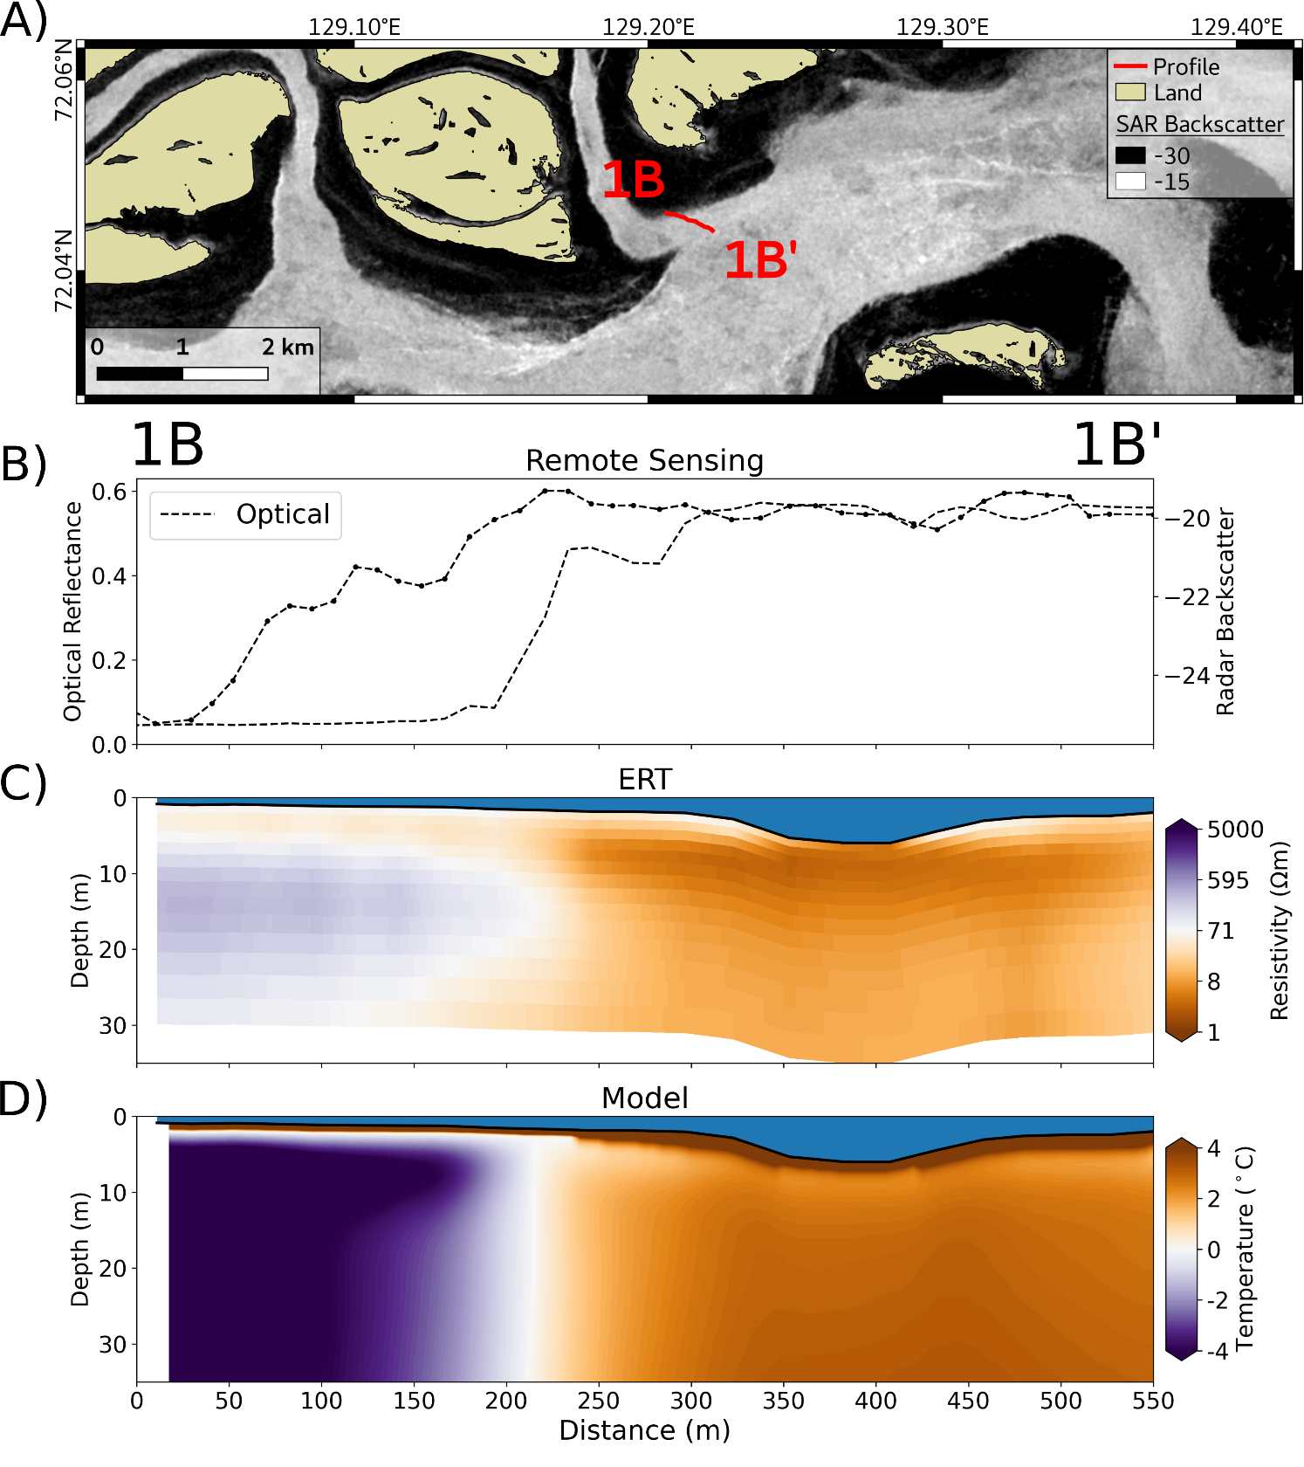

**Supplementary Figure 1**: Profile 1B - 1B’ (for the location see Figure 1). **A**) GPS track of the ERT profile on top of the SAR Sentinel-1 median winter image showing the bedfast (dark) and serpentine (bright) ice. **B**) Extracted optical reflectance and SAR backscatter along the profile. **C**) Cross section of the inverted ERT resistivity along the profile. **D**) Modelled sediment temperature along the profile.

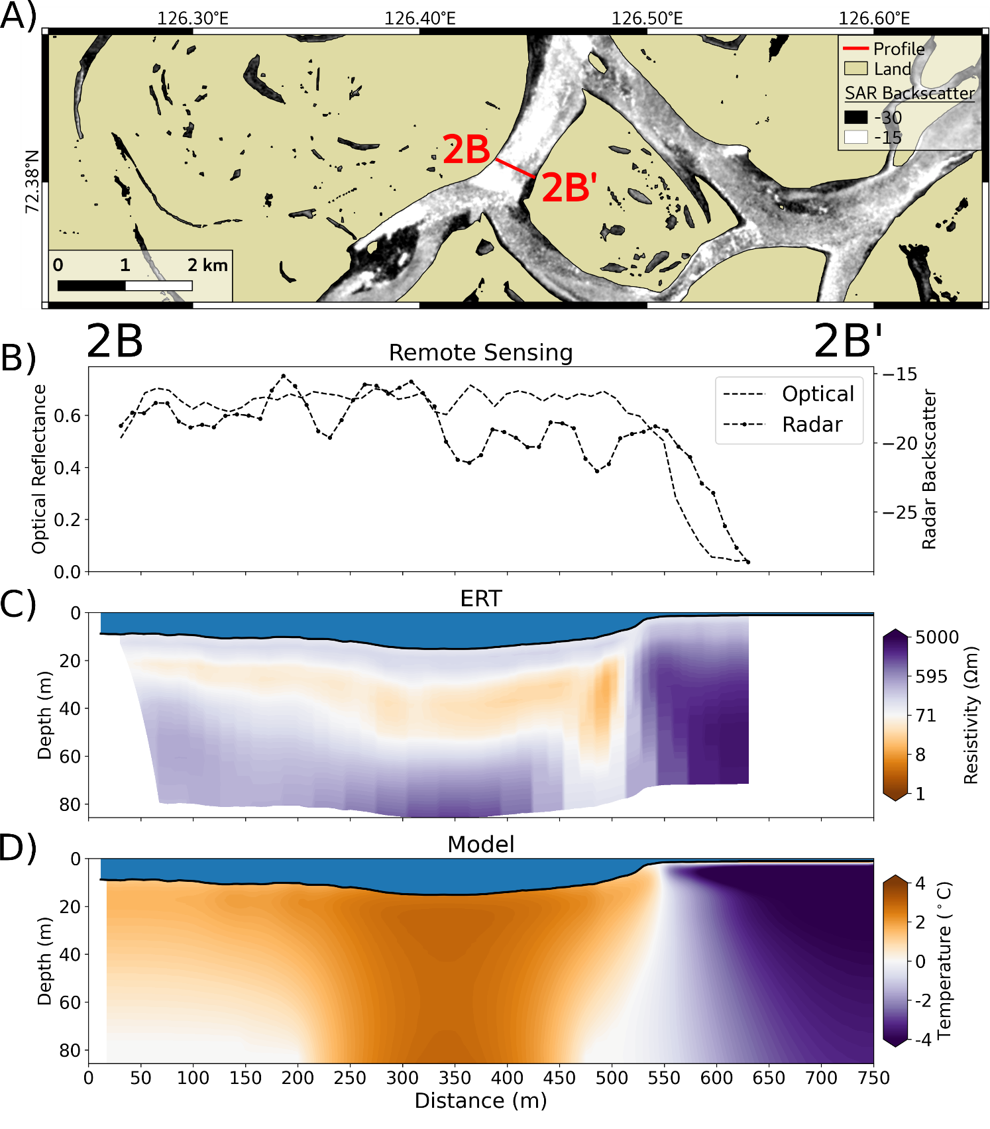

**Supplementary Figure 2**: Profile 2B - 2B’ (for the location see Figure 1). **A**) GPS track of the ERT profile on top of the SAR Sentinel-1 median winter image showing the bedfast (dark) and serpentine (bright) ice. **B**) Extracted optical reflectance and SAR backscatter along the profile. **C**) Cross section of the inverted ERT resistivity along the profile. **D**) Modelled sediment temperature along the profile.

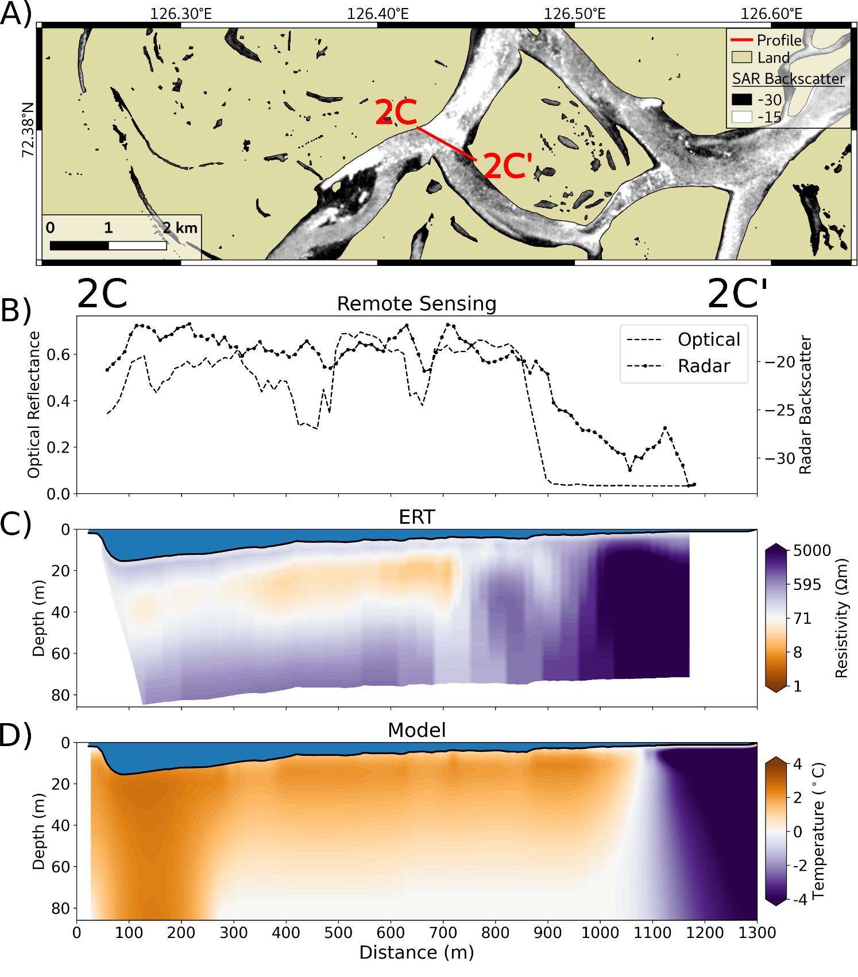

**Supplementary Figure 3**: Profile 2C - 2C’ (for the location see Figure 1). **A**) GPS track of the ERT profile on top of the SAR Sentinel-1 median winter image showing the bedfast (dark) and serpentine (bright) ice. **B**) Extracted optical reflectance and SAR backscatter along the profile. **C**) Cross section of the inverted ERT resistivity along the profile. **D**) Modelled sediment temperature along the profile.

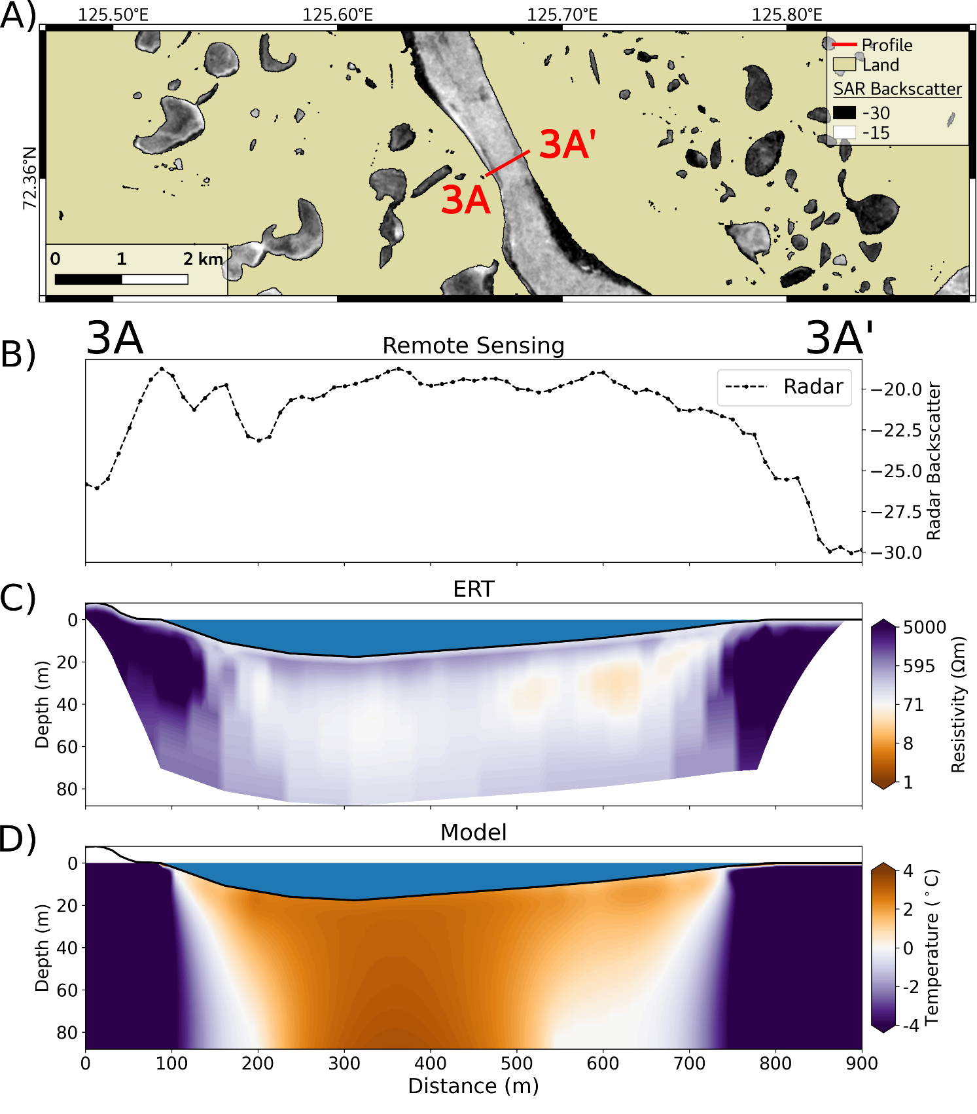

**Supplementary Figure 4**: Profile 3A - 3A’ (for the location see Figure 1). **A**) GPS track of the ERT profile on top of the SAR Sentinel-1 median winter image showing the bedfast (dark) and serpentine (bright) ice. **B**) Extracted optical reflectance and SAR backscatter along the profile. **C**) Cross section of the inverted ERT resistivity along the profile. **D**) Modelled sediment temperature along the profile.

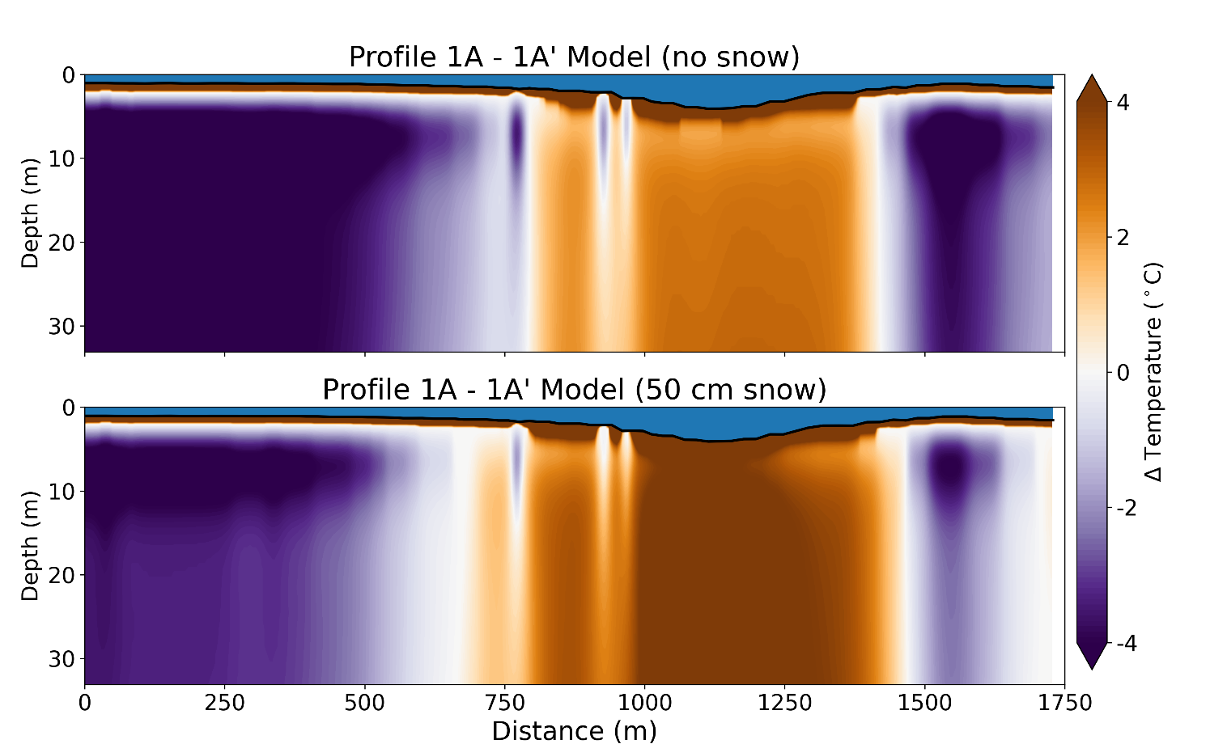

**Supplementary Figure 5**: Modelled sediment temperature along Profile 1A - 1A’ for two snow depth scenarios: no snow (upper figure) and 50 cm snow (lower figure).